

IEC 62443-3-3
Provided by : www.spic.ir
IEC 62443-3-3:2013(E)
®
Edition 1.0 2013-08

INTERNATIONAL STANDARD


colour inside

Industrial communication networks – Network and system security – Part 3-3: System security requirements and security levels


THIS PUBLICATION IS COPYRIGHT PROTECTED
Copyright © 2013 IEC, Geneva, Switzerland
All rights reserved. Unless otherwise specified, no part of this publication may be reproduced or utilized in any form or by any means, electronic or mechanical, including photocopying and microfilm, without permission in writing from either IEC or IEC's member National Committee in the country of the requester.
If you have any questions about IEC copyright or have an enquiry about obtaining additional rights to this publication, please contact the address below or your local IEC member National Committee for further information.
IEC Central Office 3, rue de Varembé CH-1211 Geneva 20 Switzerland
Tel.: +41 22 919 02 11
Fax: +41 22 919 03 00
info@iec.ch www.iec.ch

About the IEC
The International Electrotechnical Commission (IEC) is the leading global organization that prepares and publishes International Standards for all electrical, electronic and related technologies.

About IEC publications
The technical content of IEC publications is kept under constant review by the IEC. Please make sure that you have the latest edition, a corrigenda or an amendment might have been published.

Useful links:

Provided by : www.spic.ir
IEC publications search - www.iec.ch/searchpub
The advanced search enables you to find IEC publications by a variety of criteria (reference number, text, technical committee,…).
It also gives information on projects, replaced and withdrawn publications.
IEC Just Published - webstore.iec.ch/justpublished
Stay up to date on all new IEC publications. Just Published details all new publications released. Available on-line and also once a month by email.

Electropedia - www.electropedia.org
The world's leading online dictionary of electronic and electrical terms containing more than 30 000 terms and definitions in English and French, with equivalent terms in additional languages. Also known as the International Electrotechnical Vocabulary (IEV) on-line.

Customer Service Centre - webstore.iec.ch/csc
If you wish to give us your feedback on this publication or need further assistance, please contact the Customer Service Centre: csc@iec.ch.


colour inside

Industrial communication networks – Network and system security – Part 3-3: System security requirements and security levels

INTERNATIONAL ELECTROTECHNICAL COMMISSION

ICS 25.040.40; 35.110

PRICE CODE XC

ISBN 978-2-8322-1036-9

Provided by : www.spic.ir

Warning! Make sure that you obtained this publication from an authorized distributor.

® Registered trademark of the International Electrotechnical Commission

Provided by : www.spic.ir
CONTENTS
FOREWORD 9
- Introduction 11
  - Overview 11
  - Purpose and intended audience 12
  - Usage within other parts of the IEC 62443 series 12
- Scope 14
- Normative references 14
- Terms, definitions, abbreviated terms, acronyms, and conventions 14
  - Terms and definitions 14
  - Abbreviated terms and acronyms 20
  - Conventions 22
- Common control system security constraints 22
  - Overview 22
  - Support of essential functions 23
  - Compensating countermeasures 23
  - Least privilege 24
- FR 1 – Identification and authentication control 24
  - Purpose and SL-C(IAC) descriptions 24
  - Rationale 24
  - SR 1.1 – Human user identification and authentication 24
    - Requirement 24
    - Rationale and supplemental guidance 24
    - Requirement enhancements 25
    - Security levels 25
  - SR 1.2 – Software process and device identification and authentication 26
    - Requirement 26
    - Rationale and supplemental guidance 26
    - Requirement enhancements 26
    - Security levels 27
  - SR 1.3 – Account management 27
    - Requirement 27
    - Rationale and supplemental guidance 27
    - Requirement enhancements 27
    - Security levels 27
  - SR 1.4 – Identifier management 28
    - Requirement 28
    - Rationale and supplemental guidance 28
    - Requirement enhancements 28
    - Security levels 28
  - SR 1.5 – Authenticator management 28
    - Requirement 28
    - Rationale and supplemental guidance 28
    - Requirement enhancements 29
    - Security levels 29
  - SR 1.6 – Wireless access management 30
    - Requirement 30

    - Rationale and supplemental guidance 30
Provided by : www.spic.ir
    - Requirement enhancements 30
    - Security levels 30
  - SR 1.7 – Strength of password-based authentication 30
    - Requirement 30
    - Rationale and supplemental guidance 30
    - Requirement enhancements 31
    - Security levels 31
  - SR 1.8 – Public key infrastructure (PKI) certificates 31
    - Requirement 31
    - Rationale and supplemental guidance 31
    - Requirement enhancements 32
    - Security levels 32
  - SR 1.9 – Strength of public key authentication 32
    - Requirement 32
    - Rationale and supplemental guidance 32
    - Requirement enhancements 33
    - Security levels 33
  - SR 1.10 – Authenticator feedback 33
    - Requirement 33
    - Rationale and supplemental guidance 33
    - Requirement enhancements 33
    - Security levels 33
  - SR 1.11 – Unsuccessful login attempts 34
    - Requirement 34
    - Rationale and supplemental guidance 34
    - Requirement enhancements 34
    - Security levels 34
  - SR 1.12 – System use notification 34
    - Requirement 34
    - Rationale and supplemental guidance 34
    - Requirement enhancements 35
    - Security levels 35
  - SR 1.13 – Access via untrusted networks 35
    - Requirement 35
    - Rationale and supplemental guidance 35
    - Requirement enhancements 35
    - Security levels 35
- FR 2 – Use control 36
  - Purpose and SL-C(UC) descriptions 36
  - Rationale 36
  - SR 2.1 – Authorization enforcement 36
    - Requirement 36
    - Rationale and supplemental guidance 36
    - Requirement enhancements 37
    - Security levels 37
  - SR 2.2 – Wireless use control 37
    - Requirement 37
    - Rationale and supplemental guidance 38

    - Requirement enhancements 38
Provided by : www.spic.ir
    - Security levels 38
  - SR 2.3 – Use control for portable and mobile devices 38
    - Requirement 38
    - Rationale and supplemental guidance 38
    - Requirement enhancements 39
    - Security levels 39
  - SR 2.4 – Mobile code 39
    - Requirement 39
    - Rationale and supplemental guidance 39
    - Requirement enhancements 39
    - Security levels 39
  - SR 2.5 – Session lock 40
    - Requirement 40
    - Rationale and supplemental guidance 40
    - Requirement enhancements 40
    - Security levels 40
  - SR 2.6 – Remote session termination 40
    - Requirement 40
    - Rationale and supplemental guidance 40
    - Requirement enhancements 40
    - Security levels 41
  - SR 2.7 – Concurrent session control 41
    - Requirement 41
    - Rationale and supplemental guidance 41
    - Requirement enhancements 41
    - Security levels 41
  - SR 2.8 – Auditable events 41
    - Requirement 41
    - Rationale and supplemental guidance 41
    - Requirement enhancements 42
    - Security levels 42
  - SR 2.9 – Audit storage capacity 42
    - Requirement 42
    - Rationale and supplemental guidance 42
    - Requirement enhancements 42
    - Security levels 43
  - SR 2.10 – Response to audit processing failures 43
    - Requirement 43
    - Rationale and supplemental guidance 43
    - Requirement enhancements 43
    - Security levels 43
  - SR 2.11 – Timestamps 43
    - Requirement 43
    - Rationale and supplemental guidance 43
    - Requirement enhancements 44
    - Security levels 44
  - SR 2.12 – Non-repudiation 44
    - Requirement 44

    - Rationale and supplemental guidance 44
Provided by : www.spic.ir
    - Requirement enhancements 44
    - Security levels 44
- FR 3 – System integrity 45
  - Purpose and SL-C(SI) descriptions 45
  - Rationale 45
  - SR 3.1 – Communication integrity 45
    - Requirement 45
    - Rationale and supplemental guidance 45
    - Requirement enhancements 46
    - Security levels 46
  - SR 3.2 – Malicious code protection 46
    - Requirement 46
    - Rationale and supplemental guidance 46
    - Requirement enhancements 47
    - Security levels 47
  - SR 3.3 – Security functionality verification 47
    - Requirement 47
    - Rationale and supplemental guidance 47
    - Requirement enhancements 48
    - Security levels 48
  - SR 3.4 – Software and information integrity 48
    - Requirement 48
    - Rationale and supplemental guidance 48
    - Requirement enhancements 49
    - Security levels 49
  - SR 3.5 – Input validation 49
    - Requirement 49
    - Rationale and supplemental guidance 49
    - Requirement enhancements 49
    - Security levels 49
  - SR 3.6 – Deterministic output 50
    - Requirement 50
    - Rationale and supplemental guidance 50
    - Requirement enhancements 50
    - Security levels 50
  - SR 3.7 – Error handling 50
    - Requirement 50
    - Rationale and supplemental guidance 50
    - Requirement enhancements 50
    - Security levels 51
  - SR 3.8 – Session integrity 51
    - Requirement 51
    - Rationale and supplemental guidance 51
    - Requirement enhancements 51
    - Security levels 51
  - SR 3.9 – Protection of audit information 52
    - Requirement 52
    - Rationale and supplemental guidance 52

    - Requirement enhancements 52
Provided by : www.spic.ir
    - Security levels 52
- FR 4 – Data confidentiality 52
  - Purpose and SL-C(DC) descriptions 52
  - Rationale 52
  - SR 4.1 – Information confidentiality 53
    - Requirement 53
    - Rationale and supplemental guidance 53
    - Requirement enhancements 53
    - Security levels 53
  - SR 4.2 – Information persistence 54
    - Requirement 54
    - Rationale and supplemental guidance 54
    - Requirement enhancements 54
    - Security levels 54
  - SR 4.3 – Use of cryptography 54
    - Requirement 54
    - Rationale and supplemental guidance 55
    - Requirement enhancements 55
    - Security levels 55
- FR 5 – Restricted data flow 55
  - Purpose and SL-C(RDF) descriptions 55
  - Rationale 55
  - SR 5.1 – Network segmentation 56
    - Requirement 56
    - Rationale and supplemental guidance 56
    - Requirement enhancements 56
    - Security levels 57
  - SR 5.2 – Zone boundary protection 57
    - Requirement 57
    - Rationale and supplemental guidance 57
    - Requirement enhancements 57
    - Security levels 58
  - SR 5.3 – General purpose person-to-person communication restrictions 58
    - Requirement 58
    - Rationale and supplemental guidance 58
    - Requirement enhancements 58
    - Security levels 59
  - SR 5.4 – Application partitioning 59
    - Requirement 59
    - Rationale and supplemental guidance 59
    - Requirement enhancements 59
    - Security levels 59
- FR 6 – Timely response to events 59
  - Purpose and SL-C(TRE) descriptions 59
  - Rationale 60
  - SR 6.1 – Audit log accessibility 60
    - Requirement 60
    - Rationale and supplemental guidance 60

    - Requirement enhancements 60
Provided by : www.spic.ir
    - Security levels 60
  - SR 6.2 – Continuous monitoring 60
    - Requirement 60
    - Rationale and supplemental guidance 60
    - Requirement enhancements 61
    - Security levels 61
- FR 7 – Resource availability 61
  - Purpose and SL-C(RA) descriptions 61
  - Rationale 61
  - SR 7.1 – Denial of service protection 62
    - Requirement 62
    - Rationale and supplemental guidance 62
    - Requirement enhancements 62
    - Security levels 62
  - SR 7.2 – Resource management 62
    - Requirement 62
    - Rationale and supplemental guidance 62
    - Requirement enhancements 62
    - Security levels 63
  - SR 7.3 – Control system backup 63
    - Requirement 63
    - Rationale and supplemental guidance 63
    - Requirement enhancements 63
    - Security levels 63
  - SR 7.4 – Control system recovery and reconstitution 63
    - Requirement 63
    - Rationale and supplemental guidance 63
    - Requirement enhancements 64
    - Security levels 64
  - SR 7.5 – Emergency power 64
    - Requirement 64
    - Rationale and supplemental guidance 64
    - Requirement enhancements 64
    - Security levels 64
  - SR 7.6 – Network and security configuration settings 64
    - Requirement 64
    - Rationale and supplemental guidance 64
    - Requirement enhancements 65
    - Security levels 65
  - SR 7.7 – Least functionality 65
    - Requirement 65
    - Rationale and supplemental guidance 65
    - Requirement enhancements 65
    - Security levels 65
  - SR 7.8 – Control system component inventory 66
    - Requirement 66
    - Rationale and supplemental guidance 66
    - Requirement enhancements 66

    - Security levels 66
Provided by : www.spic.ir
Annex A (informative) Discussion of the SL vector 67
Annex B (informative) Mapping of SRs and REs to FR SL levels 1-4 75
Bibliography 79
Figure 1 – Structure of the IEC 62443 series 13
Figure A.1 – High-level process-industry example showing zones and conduits 69
Figure A.2 – High-level manufacturing example showing zones and conduits 70
Figure A.3 – Schematic of correlation of the use of different SL types 71
Table B.1 – Mapping of SRs and REs to FR SL levels 1-4 (1 of 4) 75

Provided by : www.spic.ir
INTERNATIONAL ELECTROTECHNICAL COMMISSION

INDUSTRIAL COMMUNICATION NETWORKS – NETWORK AND SYSTEM SECURITY –

Part 3-3: System security requirements and security levels

FOREWORD
- The International Electrotechnical Commission (IEC) is a worldwide organization for standardization comprising all national electrotechnical committees (IEC National Committees). The object of IEC is to promote international co-operation on all questions concerning standardization in the electrical and electronic fields. To this end and in addition to other activities, IEC publishes International Standards, Technical Specifications, Technical Reports, Publicly Available Specifications (PAS) and Guides (hereafter referred to as “IEC Publication(s)”). Their preparation is entrusted to technical committees; any IEC National Committee interested in the subject dealt with may participate in this preparatory work. International, governmental and non- governmental organizations liaising with the IEC also participate in this preparation. IEC collaborates closely with the International Organization for Standardization (ISO) in accordance with conditions determined by agreement between the two organizations.
- The formal decisions or agreements of IEC on technical matters express, as nearly as possible, an international consensus of opinion on the relevant subjects since each technical committee has representation from all interested IEC National Committees.
- IEC Publications have the form of recommendations for international use and are accepted by IEC National Committees in that sense. While all reasonable efforts are made to ensure that the technical content of IEC Publications is accurate, IEC cannot be held responsible for the way in which they are used or for any misinterpretation by any end user.
- In order to promote international uniformity, IEC National Committees undertake to apply IEC Publications transparently to the maximum extent possible in their national and regional publications. Any divergence between any IEC Publication and the corresponding national or regional publication shall be clearly indicated in the latter.
- IEC itself does not provide any attestation of conformity. Independent certification bodies provide conformity assessment services and, in some areas, access to IEC marks of conformity. IEC is not responsible for any services carried out by independent certification bodies.
- All users should ensure that they have the latest edition of this publication.
- No liability shall attach to IEC or its directors, employees, servants or agents including individual experts and members of its technical committees and IEC National Committees for any personal injury, property damage or other damage of any nature whatsoever, whether direct or indirect, or for costs (including legal fees) and expenses arising out of the publication, use of, or reliance upon, this IEC Publication or any other IEC Publications.
- Attention is drawn to the Normative references cited in this publication. Use of the referenced publications is indispensable for the correct application of this publication.
- Attention is drawn to the possibility that some of the elements of this IEC Publication may be the subject of patent rights. IEC shall not be held responsible for identifying any or all such patent rights.

International Standard IEC 62443-3-3 has been prepared by IEC technical committee 65: Industrial-process measurement, control and automation.

The text of this standard is based on the following documents:

FDIS | Report on voting
65/531/FDIS | 65/540/RVD

Full information on the voting for the approval of this standard can be found in the report on voting indicated in the above table.

This publication has been drafted in accordance with the ISO/IEC Directives, Part 2.

Provided by : www.spic.ir
A list of all parts in the IEC 62443 series, published under the general title Industrial communication networks – Network and system security, can be found on the IEC website.

The committee has decided that the contents of this publication will remain unchanged until the stability date indicated on the IEC web site under "http://webstore.iec.ch" in the data related to the specific publication. At this date, the publication will be
- reconfirmed,
- withdrawn,
- replaced by a revised edition, or
- amended.
A bilingual version of this publication may be issued at a later date.

The contents of the corrigendum of April 2014 have been included in this copy.

IMPORTANT – The 'colour inside' logo on the cover page of this publication indicates that it contains colours which are considered to be useful for the correct understanding of its contents. Users should therefore print this document using a colour printer.

Using SLs
When designing a new system (green field) or revising the security of an existing system (brown field), the first step is to break the system into different zones and define conduits connecting these zones where necessary. Details on how to accomplish this are given in IEC 62443‑3‑2. Once a zone model of the system is established each zone and conduit is assigned a target SL, based on a consequence analysis, which describes the desired security for the respective zone or conduit. During this initial zone and conduit analysis, it is not necessary to have completed a detailed system design. It is sufficient to describe the functionality that should be provided by assets in a zone and the connections between zones in order to meet the security objectives.

Figure A.1 and Figure A.2 show high-level examples of systems broken down into zones connected by conduits. Figure A.1 is a graphical representation of a control system for a chlorine truck loading station. The full use-case that accompanies this figure will be discussed in IEC/TR 62443‑1‑4. It has five zones shown: the basic process control system (BPCS), the SIS, the control center, the plant DMZ, and the enterprise. The BPCS and SIS both use PLCs to operate different aspects of the loading station with the SIS using a special functional safety PLC (FS-PLC) rated for use in safety systems. The two PLCs are connected via a non- routable serial or Ethernet connection using a boundary protection device. Each of the PLCs is connected to a local switch with an engineering workstation for programming and HMI for operating. The BPCS and SIS zones also contain an instrument asset management system (IAMS) to measure and test the instruments. A control center containing multiple workstations and the BPCS are both connected to the plant DMZ. A plant DMZ can house a variety of

Provided by : www.spic.ir
components and systems, for example a data historian and a maintenance workstation as shown in the figure. The plant DMZ is shown connected to the enterprise systems, which contain the corporate wireless local area network (WLAN) and web server. Multiple domain controllers and boundary protection devices are shown in the figure to indicate some of the countermeasures that may be applied to improve security.
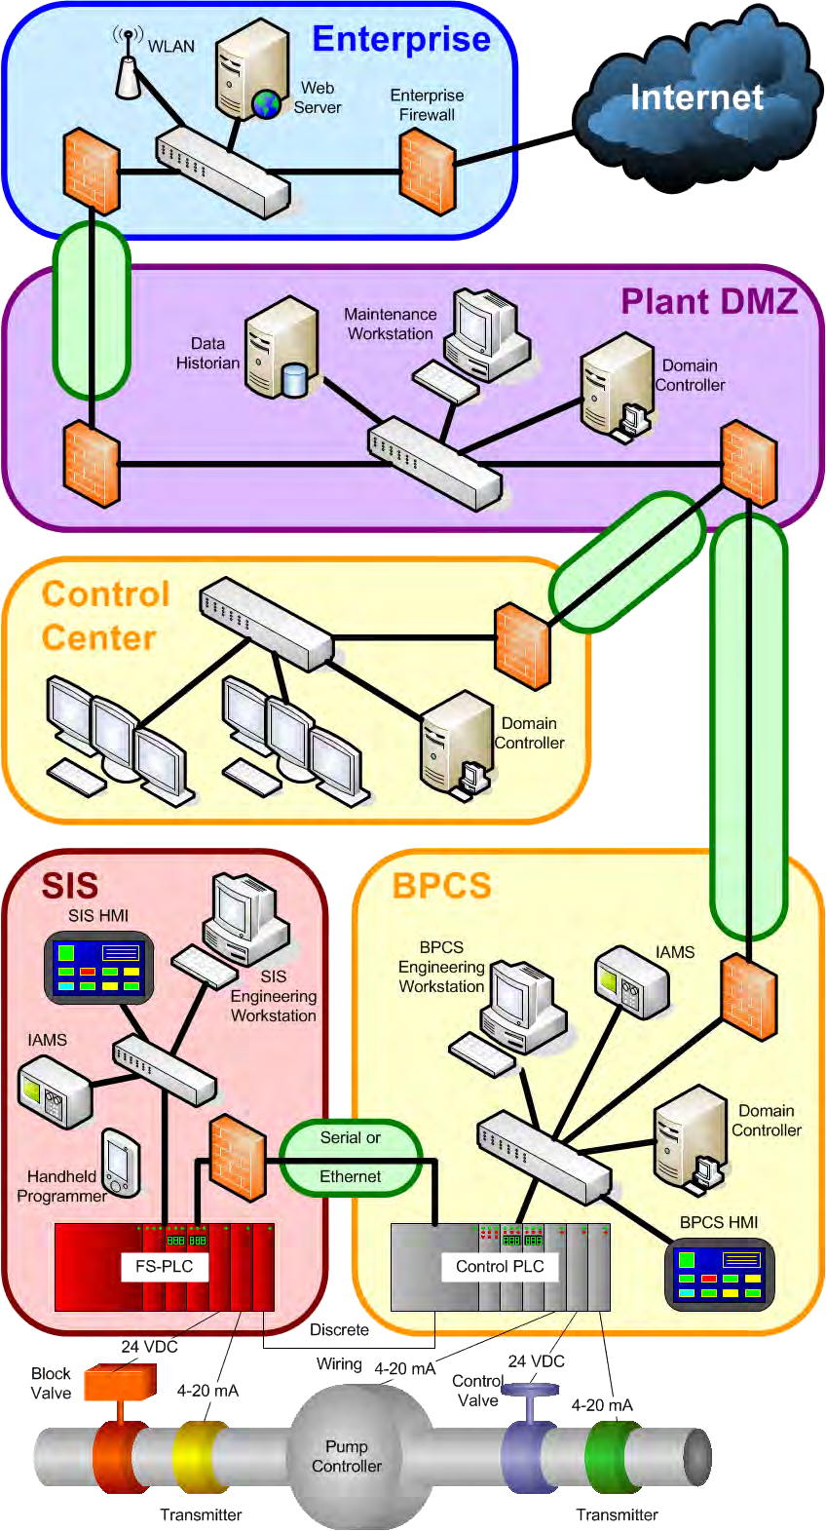
IEC 2032/13

Figure A.1 – High-level process-industry example showing zones and conduits

Figure A.2 is a graphical representation of a manufacturing plant. It has four zones defined: the enterprise network, the industrial/enterprise DMZ, and two industrial networks. The enterprise infrastructure has a WLAN and a connection to the Internet. Many companies use a DMZ between important parts of their systems to isolate the network traffic. In this particular example, each industrial network operates relatively independent of each other with its own PLC, field devices, and HMI.

Provided by : www.spic.ir
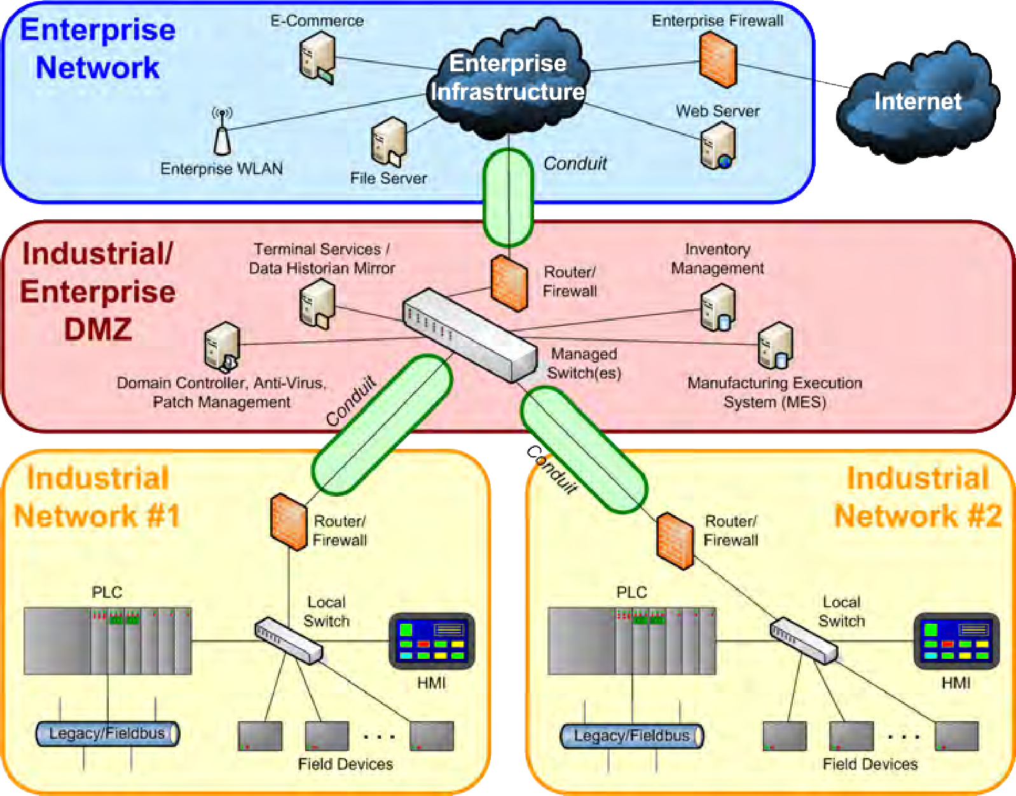
IEC 2033/13

Figure A.2 – High-level manufacturing example showing zones and conduits

After determining the target SLs, the system can be designed (green field) or redesigned (brown field) to try to meet those target SLs. The design process is usually an iterative approach where the system design is checked against the target multiple times throughout the process. Multiple parts of the IEC 62443 series contain guidance on different aspects of the programmatic and technical requirements that go into the design process. IEC 62443‑2‑1 provides guidance on the programmatic aspects of the design process while IEC 62443‑3‑3 (this standard) and IEC 62443‑4‑2 [10] define system-level and component-level technical security requirements and relate them to different capability SLs.

During the design process for a system, it is necessary to evaluate the security capabilities of different components and subsystems. Product suppliers will have to provide these as capability SLs for their components or systems by comparing features and capabilities with the requirements defined in the IEC 62443 series for the different capability SLs. These capability SLs can be used to determine whether a given component or system is capable of meeting the target SL for the system. The product supplier or system integrator will also have to provide guidance on how to configure the component or system to meet the claimed SLs.

It is likely that in a particular design there will be some components or systems that cannot fully meet the target SL. Where the capability SL of a component or system is lower than the target SL, compensating countermeasures need to be considered to meet the desired target SL. Compensating countermeasures may include changing the design of the component or system to increase its capabilities, choosing another component or system to meet the target SL or adding additional components or systems to meet the target SL. After each iteration in the design process, the system design’s achieved SLs should be reevaluated to see how they compare to the target SLs for the system.

Once the system design is approved and implemented, the system needs to be evaluated to prevent or mitigate deterioration of the system’s security level. It should be evaluated during or after system modifications and on a regular schedule. IEC 62443‑2‑1 provides guidance on the steps necessary to operate the security program and how to evaluate its effectiveness. After the achieved SLs have been determined, it will be necessary to evaluate whether the system is still meeting the original target SLs (for example, using the system requirements

Provided by : www.spic.ir
from IEC 62443‑3‑3). If the system is not meeting those requirements, there may be multiple reasons including the lack of maintenance of the program or the need to redesign parts of the system.

In essence, the control system security capabilities are determined independent from a given use context, but are used in a given context in order to achieve the target SL of the respective system architecture, zones and/or conduits (see Figure A.3).
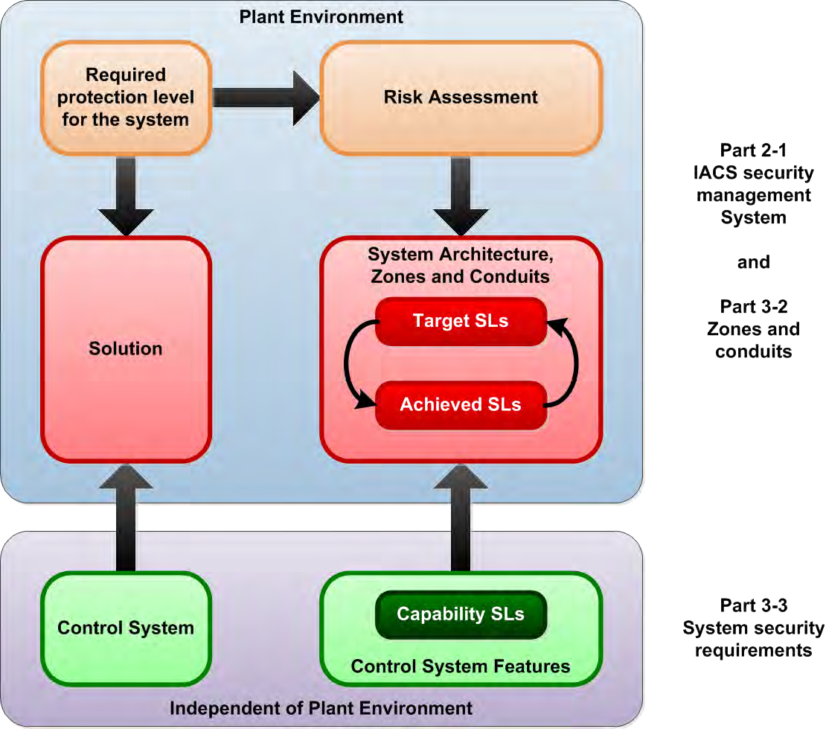
IEC 2034/13

Figure A.3 – Schematic of correlation of the use of different SL types

SL vector

Foundational requirements
SLs are based on the seven FRs for security as defined in IEC 62443‑1‑1:
- Identification and authentication control (IAC),
- Use control (UC),
- System integrity (SI),
- Data confidentiality (DC),
- Restricted data flow (RDF),
- Timely response to events (TRE), and
- Resource availability (RA).

Provided by : www.spic.ir
Instead of compressing SLs down to a single number, it is possible to use a vector of SLs that uses the seven FRs above instead of a single protection factor. This vector of SLs allows definable separations between SLs for the different FRs using language. This language can be based on the additional consequences associated with security systems or different attacks against the security objectives addressed by the FRs. The language used in the SL definitions can contain practical explanations of how one system is more secure than another without having to relate everything to HSE consequences.

Level definitions
      - Overview
The IEC 62443 series define SLs in terms of five different levels (0, 1, 2, 3 and 4), each with an increasing level of security. The current model for defining SLs depends on protecting an increasingly more complex threat and differs slightly depending on what type of SL it is applied. For SL-C, this means that a particular component or system is capable of being configured by an asset owner or system integrator to protect against an increasingly complex type of threat. For SL-T, this means that the asset owner or system integrator has determined through a risk assessment that they need to protect this particular zone, system or component against this level of threat. For SL-A, this means that the asset owner, system integrator, product supplier and/or any combination of these has configured the zone, system or component to meet the particular security requirements defined for that SL.

The language used for each of the SLs uses terms like casual, coincidental, simple, sophisticated and extended. This language is intentionally vague to allow the same basic language to be used for all of the documents in the IEC 62443 series. Each of the individual documents in the series will define the requirements for the SLs that apply to their particular purpose.

While the requirements for each of the SLs will be different throughout the IEC 62443 series, there needs to be a general understanding of what each of the SLs should protect against. The following sections will provide some guidance on how to differentiate between the SLs.

SL 0: No specific requirements or security protection necessary
SL 0 has multiple meanings depending on the situation in which it is applied. In defining SL-C it would mean that the component or system fails to meet some of the SL 1 requirements for that particular FR. This would most likely be for components or systems that would be part of a larger zone where other components or systems would provide compensating countermeasures. In defining SL-T for a particular zone it means that the asset owner has determined that the results of their risk analysis indicate that less than the full SL 1 specific requirements are necessary for that particular FR on that component or system. This would more likely happen for individual components within a system or zone that do not contribute in any way to the FR-specific requirements. In defining SL-A it would mean that the particular zone fails to meet some of the SL 1 requirements for that particular FR.

SL 1: Protection against casual or coincidental violation
Casual or coincidental violations of security are usually through the lax application of security policies. These can be caused by well-meaning employees just as easily as they can be by an outsider threat. Many of these violations will be security program related and will be handled by enforcing policies and procedures.

Using Figure A.1, a simple example would be an operator able to change a set point on the engineering station in the BPCS zone to a value outside certain conditions determined by the engineering staff. The system did not enforce the proper authentication and use control restrictions to disallow the change by the operator. Also using Figure A.1, another example would be a password being sent in clear text over the conduit between the BPCS zone and the DMZ zone, allowing a network engineer to view the password while troubleshooting the system. The system did not enforce proper data confidentiality to protect the password. Using

Provided by : www.spic.ir
Figure A.2, a third example would be an engineer that means to access the PLC in Industrial Network #1 but actually accesses the PLC in Industrial Network #2. The system did not enforce the proper restriction of data flow preventing the engineer from accessing the wrong system.

SL 2: Protection against intentional violation using simple means with low resources, generic skills and low motivation
Simple means do not require much knowledge on the part of the attacker. The attacker does not need detailed knowledge of security, the domain or the particular system under attack. These attack vectors are well known and there may be automated tools for aiding the attacker. They are also designed to attack a wide range of systems instead of targeting a specific system, so an attacker does not need a significant level of motivation or resources at hand.

Using Figure A.1, an example would be a virus that infects the maintenance workstation in the Plant DMZ zone spreading to the BPCS engineering workstation since they both use the same general purpose operating system. Using Figure A.2, another example would be an attacker compromising a web server in the enterprise network by an exploit downloaded from the Internet for a publicly known vulnerability in the general purpose operating system of the web server. The attacker uses the web server as a pivot point in an attack against other systems in the enterprise network as well as the industrial network. Also using Figure A.2, a third example would be an operator that views a website on the HMI located in Industrial Network #1 which downloads a Trojan that opens a hole in the routers and firewalls to the Internet.

SL 3: Protection against intentional violation using sophisticated means with moderate resources, IACS specific skills and moderate motivation
Sophisticated means require advanced security knowledge, advanced domain knowledge, advanced knowledge of the target system or any combination of these. An attacker going after a SL 3 system will likely be using attack vectors that have been customized for the specific target system. The attacker may use exploits in operating systems that are not well known, weaknesses in industrial protocols, specific information about a particular target to violate the security of the system or other means that require a greater motivation as well as skill and knowledge set than are required for SL 1 or 2.

An example of sophisticated means could be password or key cracking tools based on hash tables. These tools are available for download, but applying them takes knowledge of the system (such as the hash of a password to crack). Using Figure A.1, another example would be an attacker that gains access to the FS-PLC through the serial conduit after gaining access to the control PLC through a vulnerability in the Ethernet controller. Using Figure A.2, a third example would be an attacker that gains access to the data historian by using a brute- force attack through the industrial/enterprise DMZ firewall initiated from the enterprise wireless network.

SL 4: Protection against intentional violation using sophisticated means with extended resources, IACS specific skills and high motivation
SL 3 and SL 4 are very similar in that they both involve sophisticated means used to violate the security requirements of the system. The difference comes from the attacker being even more motivated and having extended resources at their disposal. These may involve high- performance computing resources, large numbers of computers or extended periods of time.

An example of sophisticated means with extended resources would be using super computers or computer clusters to conduct brute-force password cracking using large hash tables. Another example would be a botnet used to attack a system using multiple attack vectors at once. A third example would be an organized crime organization that has the motivation and resources to spend weeks attempting to analyze a system and develop custom “zero-day” exploits.

Provided by : www.spic.ir

SL vector format
A vector can be used to describe the security requirements for a zone, conduit, component or system better than a single number. This vector may contain either a specific SL requirement or a zero value for each of the foundational requirements (see A.3.1).

FORMAT → SL-?([FR,]domain) = { IAC UC SI DC RDF TRE RA }

where

SL-? = (Required) The SL type (see A.2.2). The possible formats are:
- SL-T = Target SL
- SL-A = Achieved SL
- SL-C = Capabilities SL
[FR,] = (Optional) Field indicating the FR that the SL value applies. The FRs are written out in abbreviated form instead of numerical form to aid in readability.

domain = (Required) The applicable domain that the SL applies. Domains can refer to zones, control systems, subsystems or components. Some examples of different domains from Figure A.1 are SIS zone, BPCS zone, BPCS HMI, Plant DMZ domain controller, Plant DMZ to Control Center conduit and SIS to BPCS serial conduit. In this particular standard, all requirements refer to a control system, so the domain term is not used as it would be by other documents in the IEC 62443 series.

EXAMPLE 1 → SL-T(BPCS Zone) = { 2 2 0 1 3 1 3 }

EXAMPLE 2 → SL-C(SIS Engineering Workstation) = { 3 3 2 3 0 0 1 }

EXAMPLE 3 → SL-C(RA, FS-PLC) = 4

NOTE The last example specifies only the RA component of a 7-dimension SL-C.

Provided by : www.spic.ir

Annex B
(informative)

Mapping of SRs and REs to FR SL levels 1-4

Overview

This annex is intended to provide overall guidance to the reader as to how SL levels 0 to 4 are differentiated on an FR-by-FR basis via the defined SRs and their associated REs.

SL mapping table

Table B.1 indicates which system level requirements apply to which FRs for a given system capability SL – SL-C(xx, control system). For a given FR, the required system level requirements to meet a given SL-C are denoted by a check mark. Thus, as an example, the SL=1 system security capabilities for FR 5 (or SL-C(RDF, control system)=1), would include the base requirements of all four defined SRs. A system unable to meet all four of these SRs would have an SL-C(RDF, control system)=0. To meeting SL-C(RDF, control system)=2, a system needs to support the four SR base requirements plus RE(1) of SR 5.1 and SR 5.2. As another example, only the SR 6.1 base requirement is required to meet SL-C(TRE, control system)=1, but both SRs defined are required in order to meet SL-C(TRE, control system)=2. Refer to A.3.3 for how a full SL vector would be denoted.

Table B.1 – Mapping of SRs and REs to FR SL levels 1-4 (1 of 4)

 |  | SRs and REs |  | SL 1 | SL 2 | SL 3 | SL 4
FR 1 – Identification and authentication control (IAC)
SR 1.1 – Human user identification and authentication |  |  | 5.3 | ✓ | ✓ | ✓ | ✓
SR 1.1 RE 1 – Unique identification and authentication |  |  | 5.3.3.1 |  | ✓ | ✓ | ✓
SR 1.1 RE 2 – Multifactor authentication for untrusted networks |  |  | 5.3.3.2 |  |  | ✓ | ✓
SR 1.1 RE 3 – Multifactor authentication for all networks |  |  | 5.3.3.3 |  |  |  | ✓
SR 1.2 – Software process and device identification and authentication |  |  | 5.4 |  | ✓ | ✓ | ✓
SR 1.2 RE 1 – Unique identification and authentication |  |  | 5.4.3.1 |  |  | ✓ | ✓
SR 1.3 – Account management |  |  | 5.5 | ✓ | ✓ | ✓ | ✓
SR 1.3 RE 1 – Unified account management |  |  | 5.5.3.1 |  |  | ✓ | ✓
SR 1.4 – Identifier management |  |  | 5.6 | ✓ | ✓ | ✓ | ✓
SR 1.5 – Authenticator management |  |  | 5.7 | ✓ | ✓ | ✓ | ✓
SR 1.5 RE 1 – Hardware security for software process identity credentials |  |  | 5.7.3.1 |  |  | ✓ | ✓
SR | 1.6 | – Wireless access management | 5.8 | ✓ | ✓ | ✓ | ✓
SR 1.6 RE 1 – Unique identification and authentication |  |  | 5.8.3.1 |  | ✓ | ✓ | ✓
SR 1.7 – Strength of password-based authentication |  |  | 5.9 | ✓ | ✓ | ✓ | ✓
SR 1.7 RE 1 – Password generation and lifetime restrictions for human users |  |  | 5.9.3.1 |  |  | ✓ | ✓

Provided by : www.spic.ir
Table B.1 (2 of 4)

SRs and REs |  | SL 1 | SL 2 | SL 3 | SL 4
SR 1.7 RE 2 – Password lifetime restrictions for all users | 5.9.3.2 |  |  |  | ✓
SR 1.8 – Public key infrastructure certificates | 5.10 |  | ✓ | ✓ | ✓
SR 1.9 – Strength of public key authentication | 5.11 |  | ✓ | ✓ | ✓
SR 1.9 RE 1 – Hardware security for public key authentication | 5.11.3.1 |  |  | ✓ | ✓
SR 1.10 – Authenticator feedback | 5.12 | ✓ | ✓ | ✓ | ✓
SR 1.11 – Unsuccessful login attempts | 5.13 | ✓ | ✓ | ✓ | ✓
SR 1.12 – System use notification | 5.14 | ✓ | ✓ | ✓ | ✓
SR 1.13 – Access via untrusted networks | 5.15 | ✓ | ✓ | ✓ | ✓
SR 1.13 RE 1 – Explicit access request approval | 5.15.3.1 |  | ✓ | ✓ | ✓
FR 2 – Use control (UC)
SR 2.1 – Authorization enforcement | 6.3 | ✓ | ✓ | ✓ | ✓
SR 2.1 RE 1 – Authorization enforcement for all users | 6.3.3.1 |  | ✓ | ✓ | ✓
SR 2.1 RE 2 – Permission mapping to roles | 6.3.3.2 |  | ✓ | ✓ | ✓
SR 2.1 RE 3 – Supervisor override | 6.3.3.3 |  |  | ✓ | ✓
SR 2.1 RE 4 – Dual approval | 6.3.3.4 |  |  |  | ✓
SR 2.2 – Wireless use control | 6.4 | ✓ | ✓ | ✓ | ✓
SR 2.2 RE 1 – Identify and report unauthorized wireless devices | 6.4.3.1 |  |  | ✓ | ✓
SR 2.3 – Use control for portable and mobile devices | 6.5 | ✓ | ✓ | ✓ | ✓
SR 2.3 RE 1 – Enforcement of security status of portable and mobile devices | 6.5.3.1 |  |  | ✓ | ✓
SR 2.4 – Mobile code | 6.6 | ✓ | ✓ | ✓ | ✓
SR 2.4 RE 1 – Mobile code integrity check | 6.6.3.1 |  |  | ✓ | ✓
SR 2.5 – Session lock | 6.7 | ✓ | ✓ | ✓ | ✓
SR 2.6 – Remote session termination | 6.8 |  | ✓ | ✓ | ✓
SR 2.7 – Concurrent session control | 6.9 |  |  | ✓ | ✓
SR 2.8 – Auditable events | 6.10 | ✓ | ✓ | ✓ | ✓
SR 2.8 RE 1 – Centrally managed, system-wide audit trail | 6.10.3.1 |  |  | ✓ | ✓
SR 2.9 – Audit storage capacity | 6.11 | ✓ | ✓ | ✓ | ✓
SR 2.9 RE 1 – Warn when audit record storage capacity threshold reached | 6.11.3.1 |  |  | ✓ | ✓
SR 2.10 – Response to audit processing failures | 6.12 | ✓ | ✓ | ✓ | ✓
SR 2.11 – Timestamps | 6.13 |  | ✓ | ✓ | ✓
SR 2.11 RE 1 – Internal time synchronization | 6.13.3.1 |  |  | ✓ | ✓
SR 2.11 RE 2 – Protection of time source integrity | 6.13.3.2 |  |  |  | ✓
SR 2.12 – Non-repudiation | 6.14 |  |  | ✓ | ✓
SR 2.12 RE 1 – Non-repudiation for all users | 6.14.3.1 |  |  |  | ✓

Provided by : www.spic.ir
Table B.1 (3 of 4)

SRs and REs SL 1 SL 2 SL 3 SL 4
FR 3 – System integrity (SI)
SR 3.1 – Communication integrity | 7.3 | ✓ | ✓ | ✓ | ✓
SR 3.1 RE 1 – Cryptographic integrity protection | 7.3.3.1 |  |  | ✓ | ✓
SR 3.2 – Malicious code protection | 7.4 | ✓ | ✓ | ✓ | ✓
SR 3.2 RE 1 – Malicious code protection on entry and exit points | 7.4.3.1 |  | ✓ | ✓ | ✓
SR 3.2 RE 2 – Central management and reporting for malicious code protection | 7.4.3.2 |  |  | ✓ | ✓
SR 3.3 – Security functionality verification | 7.5 | ✓ | ✓ | ✓ | ✓
SR 3.3 RE 1 – Automated mechanisms for security functionality verification | 7.5.3.1 |  |  | ✓ | ✓
SR 3.3 RE 2 – Security functionality verification during normal operation | 7.5.3.2 |  |  |  | ✓
SR 3.4 – Software and information integrity | 7.6 |  | ✓ | ✓ | ✓
SR 3.4 RE 1 – Automated notification about integrity violations | 7.6.3.1 |  |  | ✓ | ✓
SR 3.5 – Input validation | 7.7 | ✓ | ✓ | ✓ | ✓
SR 3.6 – Deterministic output | 7.8 | ✓ | ✓ | ✓ | ✓
SR 3.7 – Error handling | 7.9 |  | ✓ | ✓ | ✓
SR 3.8 – Session integrity | 7.10 |  | ✓ | ✓ | ✓
SR 3.8 RE 1 – Invalidation of session IDs after session termination | 7.10.3.1 |  |  | ✓ | ✓
SR 3.8 RE 2 – Unique session ID generation | 7.10.3.2 |  |  | ✓ | ✓
SR 3.8 RE 3 – Randomness of session IDs | 7.10.3.3 |  |  |  | ✓
SR 3.9 – Protection of audit information | 7.11 |  | ✓ | ✓ | ✓
SR 3.9 RE 1 – Audit records on write-once media | 7.11.3.1 |  |  |  | ✓
FR 4 – Data confidentiality (DC)
SR 4.1 – Information confidentiality | 8.3 | ✓ | ✓ | ✓ | ✓
SR 4.1 RE 1 – Protection of confidentiality at rest or in transit via untrusted networks | 8.3.3.1 |  | ✓ | ✓ | ✓
SR 4.1 RE 2 – Protection of confidentiality across zone boundaries | 8.3.3.2 |  |  |  | ✓
SR 4.2 – Information persistence | 8.4 |  | ✓ | ✓ | ✓
SR 4.2 RE 1 – Purging of shared memory resources | 8.4.3.1 |  |  | ✓ | ✓
SR 4.3 – Use of cryptography | 8.5 | ✓ | ✓ | ✓ | ✓
FR 5 – Restricted data flow (RDF)
SR 5.1 – Network segmentation | 9.3 | ✓ | ✓ | ✓ | ✓
SR 5.1 RE 1 – Physical network segmentation | 9.3.3.1 |  | ✓ | ✓ | ✓
SR 5.1 RE 2 – Independence from non-control system networks | 9.3.3.2 |  |  | ✓ | ✓
SR 5.1 RE 3 – Logical and physical isolation of critical networks | 9.3.3.3 |  |  |  | ✓

Provided by : www.spic.ir
Table B.1 (4 of 4)

SRs and REs |  | SL 1 | SL 2 | SL 3 | SL 4
SR 5.2 – Zone boundary protection | 9.4 | ✓ | ✓ | ✓ | ✓
SR 5.2 RE 1 – Deny by default, allow by exception | 9.4.3.1 |  | ✓ | ✓ | ✓
SR 5.2 RE 2 – Island mode | 9.4.3.2 |  |  | ✓ | ✓
SR 5.2 RE 3 – Fail close | 9.4.3.3 |  |  | ✓ | ✓
SR 5.3 – General purpose person-to-person communication restrictions | 9.5 | ✓ | ✓ | ✓ | ✓
SR 5.3 RE 1 – Prohibit all general purpose person- to-person communications | 9.5.3.1 |  |  | ✓ | ✓
SR 5.4 – Application partitioning | 9.6 | ✓ | ✓ | ✓ | ✓
FR 6 – Timely response to events (TRE)
SR 6.1 – Audit log accessibility | 10.3 | ✓ | ✓ | ✓ | ✓
SR 6.1 RE 1 – Programmatic access to audit logs | 10.3.3.1 |  |  | ✓ | ✓
SR 6.2 – Continuous monitoring | 10.4 |  | ✓ | ✓ | ✓
FR 7 – Resource availability (RA)
SR 7.1 – Denial of service protection | 11.3 | ✓ | ✓ | ✓ | ✓
SR 7.1 RE 1 – Manage communication loads | 11.3.3.1 |  | ✓ | ✓ | ✓
SR 7.1 RE 2 – Limit DoS effects to other systems or networks | 11.3.3.2 |  |  | ✓ | ✓
SR 7.2 – Resource management | 11.4 | ✓ | ✓ | ✓ | ✓
SR 7.3 – Control system backup | 11.5 | ✓ | ✓ | ✓ | ✓
SR 7.3 RE 1 – Backup verification | 11.5.3.1 |  | ✓ | ✓ | ✓
SR 7.3 RE 2 – Backup automation | 11.5.3.2 |  |  | ✓ | ✓
SR 7.4 – Control system recovery and reconstitution | 11.6 | ✓ | ✓ | ✓ | ✓
SR 7.5 – Emergency power | 11.7 | ✓ | ✓ | ✓ | ✓
SR 7.6 – Network and security configuration settings | 11.8 | ✓ | ✓ | ✓ | ✓
SR 7.6 RE 1 – Machine-readable reporting of current security settings | 11.8.3.1 |  |  | ✓ | ✓
SR 7.7 – Least functionality | 11.9 | ✓ | ✓ | ✓ | ✓
SR 7.8 – Control system component inventory | 11.10 |  | ✓ |  | ✓

Provided by : www.spic.ir
Provided by : www.spic.ir

